
O’ZBEKISTON RESPUBLIKASI OLIY TA’LIM, FAN VA INNOVATSIYA VAZIRLIGI
ABU RAYXON BERUNIY NOMIDAGI URGANCH DAVLAT UNIVERSITETI

Kompyuter injineringgi fakulteti
„Kompyuter ilmlari va dasturlash texnologiyalari” yo’nalishi 234-guruh
Rustamova Shahrizoda
“Web texnologiyalar ” fanidan
4-laboratoriya mashg’uloti

Qabul qildi: ________________________________________________

Urganch-2025

Mavzu: Jadval yaratish va uni formatlash
Ishdan maqsad:
HTML va CSS yordamida jadval yaratish va uni estetik tarzda formatlashni o‘rganish, veb-sahifalarda ma’lumotlarni tartibli va ko‘rinimli tarzda taqdim etish ko‘nikmasini shakllantirish.
Nazariy qism:
HTML jadvali — bu ma’lumotlarni satr va ustunlarda tartib bilan ko‘rsatish uchun ishlatiladigan tuzilma. Jadval odatda statistik ma’lumotlar, ro‘yxatlar yoki taqqoslashlar uchun qulay.
Asosiy teglar
Teg | Maqsadi
<table> | Jadvalni boshlaydi
<tr> | Satr (row) yaratadi
<th> | Sarlavha hujayrasi (bold va markaziy)
<td> | Oddiy hujayra (data)
<thead> | Jadval sarlavhalari uchun guruh
<tbody> | Jadval tanasi (asosiy ma’lumotlar)
<tfoot> | Jadval pastki qismi (masalan, umumiy natija)
HTMLda jadval quyidagi tartibda yoziladi:
html
<table>
<thead>
<tr>
<th>Ustun 1</th>
<th>Ustun 2</th>
</tr>
</thead>
<tbody>
<tr>
<td>Ma’lumot 1</td>
<td>Ma’lumot 2</td>
</tr>
</tbody></table>
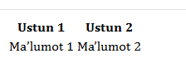

Jadval formatlash usullari
Xususiyat | CSS Qoidasi
Chegaralar | border: 1px solid black;
Ichki bo‘shliq | padding: 10px;
Matnni joylash | text-align: center;
Fon rangi | background-color: #f2f2f2;
Satr navbati bilan | nth-child(even) yoki odd
Hover effekti | tr:hover { background-color: ... }
Laboratoriya ishini bajarish:
Bugungi laboratoriya ishida web sahifalarda qanday jadvallarni yaratishni va web sahifani o’zini ham jadval ko’rinishida yaratish mumkinligini o’rgandik. Mening mavzuyim “Kutubxona.uz” sayti va bugungi mavzu yordamida kitoblar jadvalini qo’shdim.
Kodi:
<<head>
<meta charset="UTF-8">
<meta name="viewport" content="width=device-width, initial-scale=1.0">
<title>Eng Mashhur Kitoblar</title>
<style>
body {
font-family: "Poppins", sans-serif;
background: linear-gradient(135deg, #f0f4f8, #d9e2ec);
margin: 0;
padding: 40px;
color: #333;
}
h1 {
text-align: center;
color: #2c3e50;
font-size: 36px;
letter-spacing: 1px;
margin-bottom: 25px;
text-shadow: 1px 1px 2px #ccc;
}
table {
width: 90%;
margin: 0 auto;
border-collapse: collapse;
background: white;
border-radius: 12px;
overflow: hidden;
box-shadow: 0 4px 20px rgba(0,0,0,0.15);
animation: fadeIn 1s ease-in-out;
}
thead {
background: linear-gradient(90deg, #1d3557, #457b9d);
color: white;
}
th, td {
padding: 14px 18px;
text-align: left;
}
th {
text-align: center;
font-size: 18px;
text-transform: uppercase;
letter-spacing: 1px;
}
tbody tr:nth-child(even) {
background-color: #f5f9fc;
}
tbody tr:hover {
background-color: #eaf3fa;
transform: scale(1.01);
transition: all 0.2s ease-in-out;
}
td {
border-bottom: 1px solid #eee;
}
tfoot {
background: #1d3557;
color: #fff;
text-align: center;
font-style: italic;
padding: 12px;
}
a {
color: #1d70b8;
text-decoration: none;
font-weight: 500;
}
a:hover {
text-decoration: underline;
color: #0b4a75;
}
/* animatsiya */
@keyframes fadeIn {
from {opacity: 0; transform: translateY(-20px);}
to {opacity: 1; transform: translateY(0);}
}
</style>
</head>
<body>
<h1>🌍 Eng mashhur kitoblar</h1>
<table>
<thead>
<tr>
<th>№</th>
<th>Kitob nomi</th>
<th>Muallif</th>
<th>Janr</th>
<th>Yili</th>
<th>Havola</th>
</tr>
</thead>
<tbody>
<tr>
<td>1</td>
<td><strong>Don Kixot</strong></td>
<td>Migel de Servantes</td>
<td>Roman, Satira</td>
<td>1605</td>
<td><a href="https://uz.wikipedia.org/wiki/Don_Kixot" target="_blank">Ko‘rish</a></td>
</tr>
<tr>
<td>2</td>
<td><strong>Usta va Margarita</strong></td>
<td>Mixael Bulgakov</td>
<td>Fantastika, Falsafiy roman</td>
<td>1966</td>
<td><a href="https://uz.wikipedia.org/wiki/Usta_va_Margarita" target="_blank">Ko‘rish</a></td>
</tr>
<tr>
<td>3</td>
<td><strong>Urush va Tinchlik</strong></td>
<td>Lev Tolstoy</td>
<td>Tarixiy roman</td>
<td>1869</td>
<td><a href="https://uz.wikipedia.org/wiki/Urush_va_tinchlik" target="_blank">Ko‘rish</a></td>
</tr>
<tr>
<td>4</td>
<td><strong>G‘urur va G‘araz</strong></td>
<td>Jeyn Ostin</td>
<td>Romantik roman</td>
<td>1813</td>
<td><a href="https://uz.wikipedia.org/wiki/G%CA%BBurur_va_g%CA%BBaraz" target="_blank">Ko‘rish</a></td>
</tr>
<tr>
<td>5</td>
<td><strong>1984</strong></td>
<td>Jorj Oruell</td>
<td>Distrofiya, Siyosiy roman</td>
<td>1949</td>
<td><a href="https://uz.wikipedia.org/wiki/1984_(roman)" target="_blank">Ko‘rish</a></td>
</tr>
<tr>
<td>6</td>
<td><strong>Alkimyogar</strong></td>
<td>Paulo Koelo</td>
<td>Ilhomlantiruvchi, Falsafiy roman</td>
<td>1988</td>
<td><a href="https://uz.wikipedia.org/wiki/Alkimyogar" target="_blank">Ko‘rish</a></td>
</tr>
<tr>
<td>7</td>
<td><strong>Harry Potter va Sehrgarlar Toshi</strong></td>
<td>J. K. Rowling</td>
<td>Fantastika</td>
<td>1997</td>
<td><a href="https://uz.wikipedia.org/wiki/Harry_Potter" target="_blank">Ko‘rish</a></td>
</tr>
<tr>
<td>8</td>
<td><strong>O‘tkan kunlar</strong></td>
<td>Abdulla Qodiriy</td>
<td>Tarixiy, Romantik roman</td>
<td>1925</td>
<td><a href="https://uz.wikipedia.org/wiki/O%CA%BBtkan_kunlar" target="_blank">Ko‘rish</a></td>
</tr>
<tr>
<td>9</td>
<td><strong>Shaytanat</strong></td>
<td>Tohir Malik</td>
<td>Detektiv, Ijtimoiy roman</td>
<td>1993</td>
<td><a href="https://uz.wikipedia.org/wiki/Shaytanat" target="_blank">Ko‘rish</a></td>
</tr>
<tr>
<td>10</td>
<td><strong>Kichkina Shahzoda</strong></td>
<td>Antuan de Sent-Ekzyuperi</td>
<td>Falsafiy ertak</td>
<td>1943</td>
<td><a href="https://uz.wikipedia.org/wiki/Kichkina_shahzoda" target="_blank">Ko‘rish</a></td>
</tr>
</tbody>
<tfoot>
<tr>
<td colspan="6">© 2025 Eng mashhur kitoblar — <i>Bilim manbai</i></td>
</tr>
</tfoot>
</table>
</body>
Ko’rinishi:
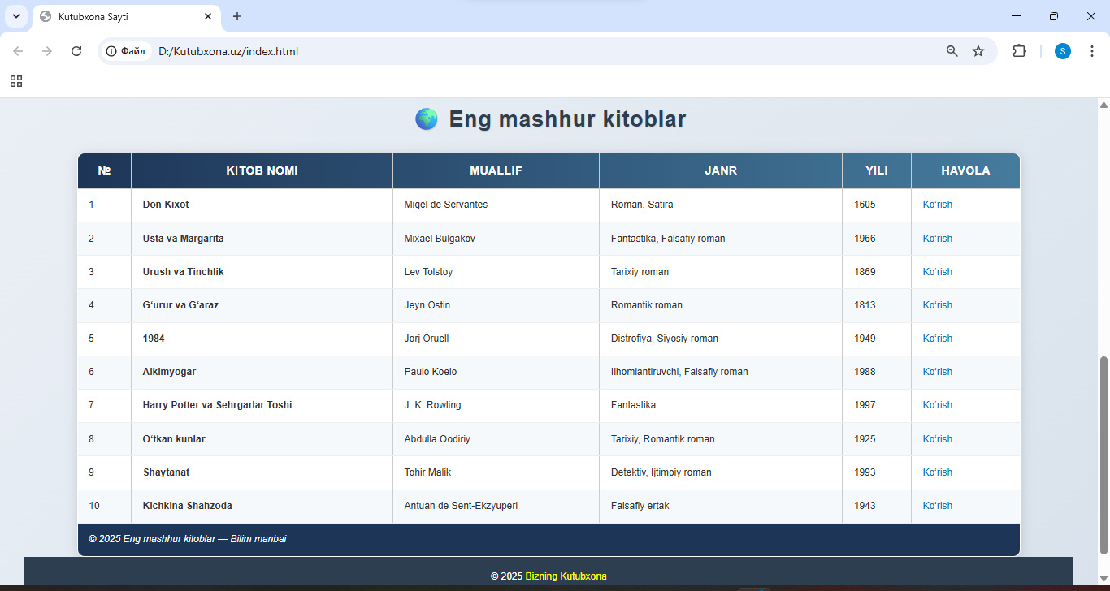
Xulosa
Ushbu laboratoriya ishini bajarish davomida men HTML va CSS yordamida jadval yaratish, uni estetik tarzda bezatish va ma’lumotlarni tartibli shaklda joylashtirish bo‘yicha amaliy ko‘nikmalarga ega bo‘ldim. Jadval tuzilmasidagi <table>, <tr>, <th>, <td>, <thead>, <tbody> va <tfoot> kabi teglarning vazifalarini amalda qo‘llab, ularning har biri sahifa dizayniga qanday ta’sir qilishini o‘rgandim.
Ish davomida “Eng mashhur kitoblar” mavzusida o‘ziga xos jadval yaratdim. Unda kitoblarning nomi, muallifi, janri, chop etilgan yili va havolalari ko‘rinimli tarzda joylashtirildi. Jadvalni zamonaviy uslubda bezash uchun CSS orqali fon gradienti, hover effekti, soyalar va yumaloq burchaklardan foydalandim.

